G PARTED EXERCISE 29/10

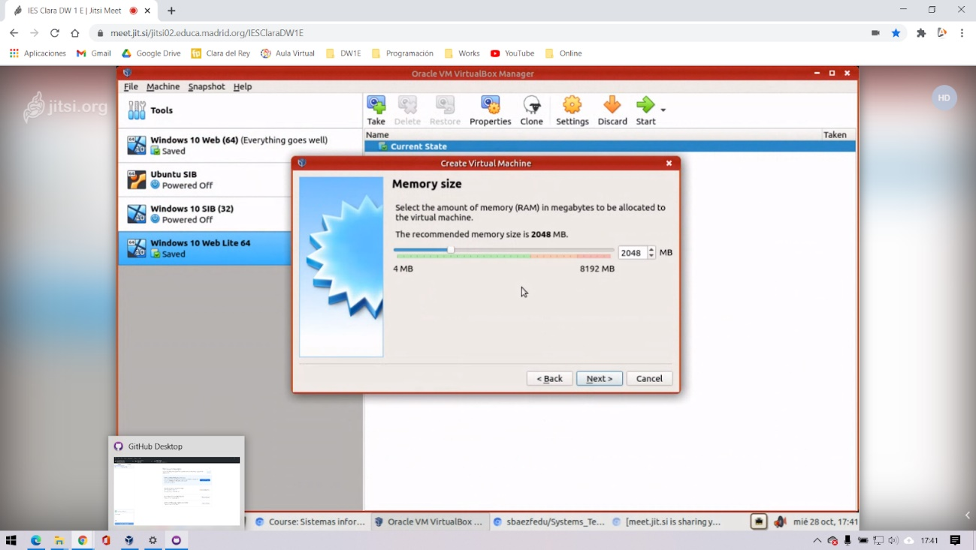

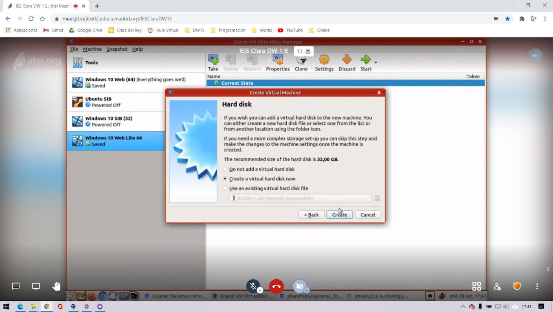

HERE I CHANGE THE SCREENSHOT BECAUSE I MADE THIS EXERCISE WITH WINDOWS7 INSTEAD OF WINDOWS 10 AS IN THE PREVIOUS PHOTOS.

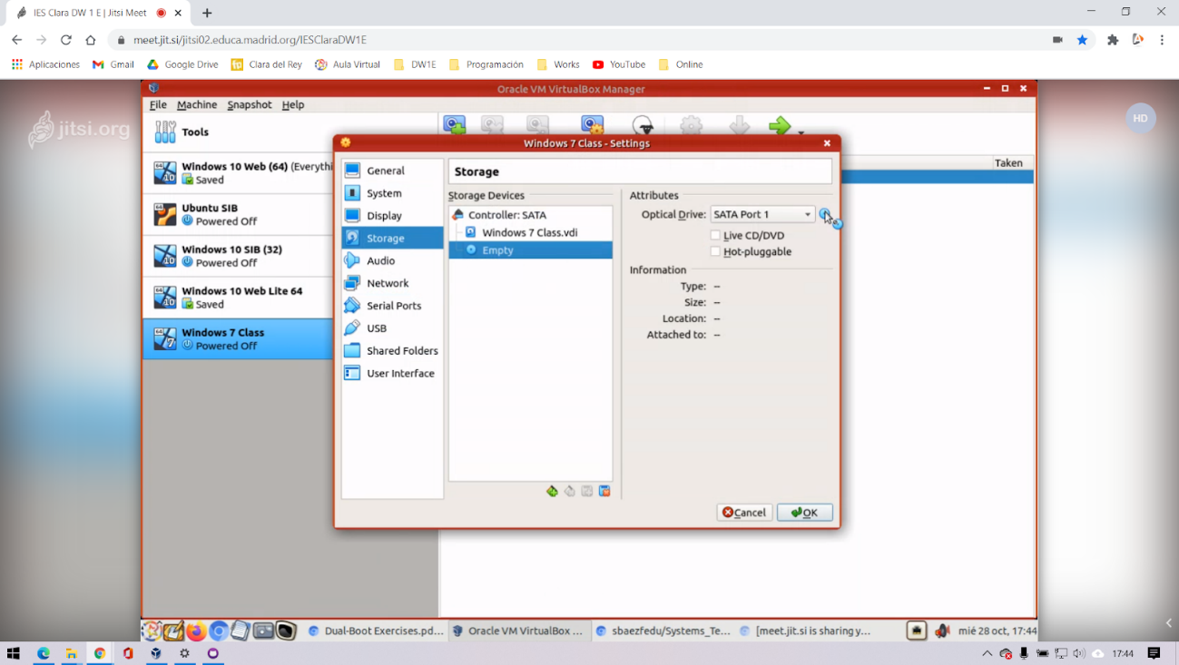

WE HAVE TO SET THE DRBL SYSTEM AND ADDED TO THE STORAGE OF OUR VIRTUAL MACHINE

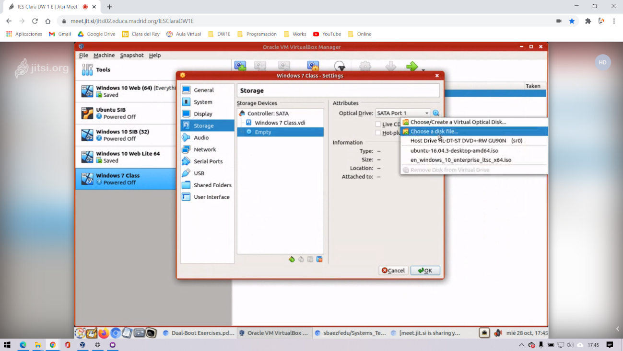

WE HAVE TO RUN AGAIN THE MACHINE WHERE WE CAN SEE THE NEW RBL WHERE WE CAN MAKE DE PARTITIONS. WE HAVE TO INSTALL IT PROPERLY.

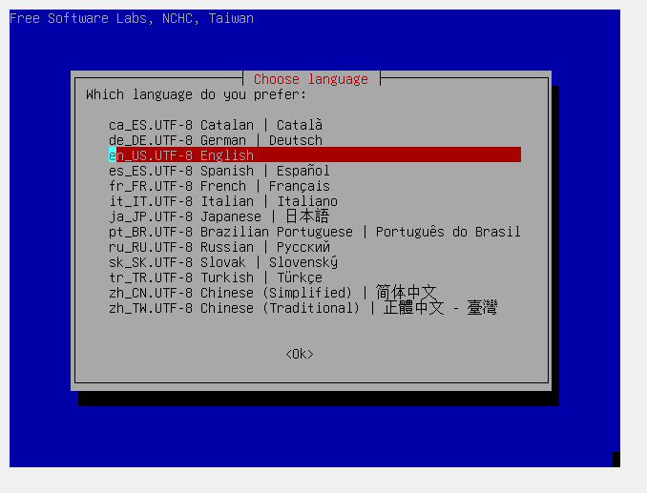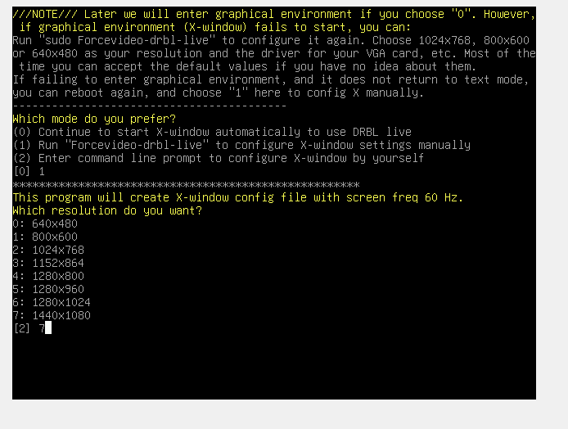

THEN WE CHOSE THE PARTITIONS AND THE TYPES THAT WE WANT. WE MUST PRESS THE GREEN TIC TO SAVE AL THE CHANGES!

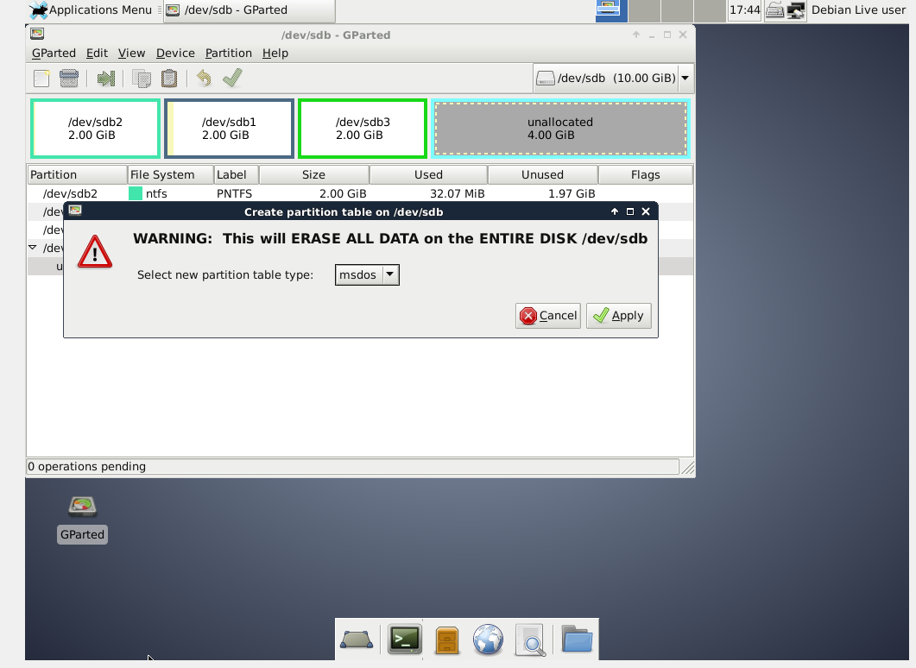

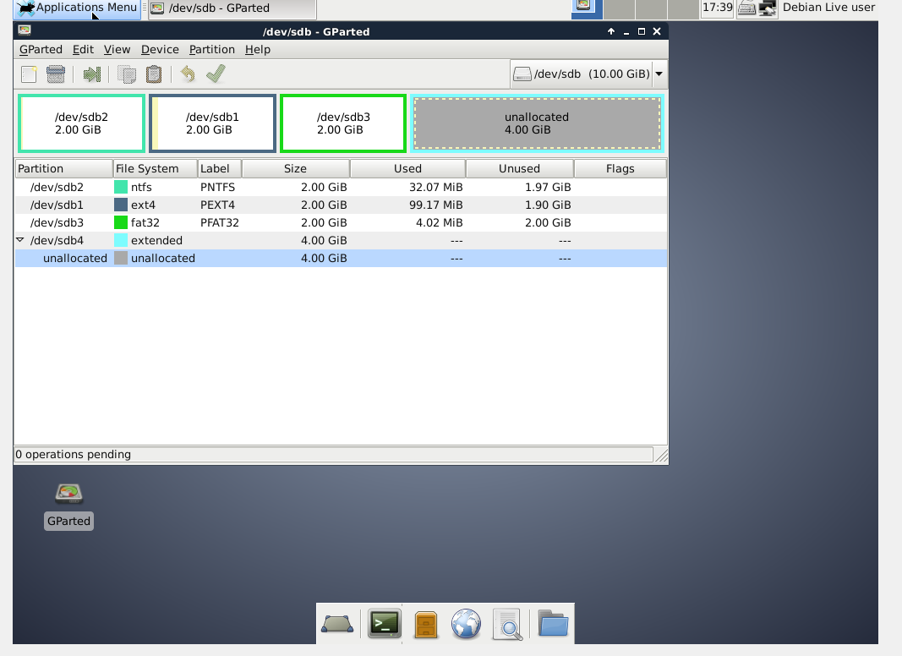

FINALLY WE OPEN AGAIN WINDOWS 7 TO SEE IN THE DISK MANAGMENT IF THE PARTITION IS OK

